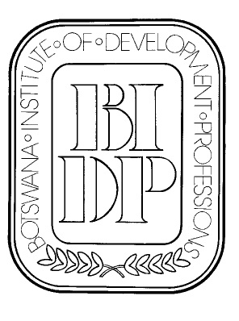
BOTSWANA INSTITUTE OF DEVELOPMENT PROFESSIONS

P.O. Box 827

Gaborone

Fax: 3971181
Mobile (Executive secretary): 7181 6811
e-mail: bidp@mega.bw
website: http//www.bidp.bw

REPORT OF THE BIDP PRESIDENT
TO THE 2010 ANNUAL GENERAL MEETING

Good evening ladies and gentlemen and welcome to the 32nd BIDP AGM.

I would like to begin by thanking all those who have taken the time to come to the AGM, and also those who have not been able to come but have sent proxy forms.

We have again been had a busy year and have been able to get the ball rolling on a number of initiatives that will hopefully be carried further in the coming year and beyond.

Competition.
The concept of a BIDP competition has been given much attention by Council, and there are now two possible competitions in the planning stages. A competition for ideas for sustainable living is intended to be open for all students in the country. It is intended to encourage people to think about how our lives need to change in order to reduce consumption of non-renewable resources and move towards a long term sustainable lifestyle.

A competition for photographs that illustrate ‘Quality in Development’ was officially launched today. It is open to all, and entrants may submit photos by email. Photos that are accepted for consideration will be posted on our website, and the entries that are shortlisted for winning will be displayed at an exhibition early next year.

BIDP Website.
The website has been completely re-constructed and now has several new features, with more to come. A forum facility allows interactive discussion on topics of interest to members and others. A discussion has been posted regarding the size of bricks which has raised interesting questions regarding the history of the brick, and how to reduce waste in building construction. Opportunities for accessing some publications on-line will also be developed. The list of members and practices is still available on the website, and members are encouraged to check the details and let us know if there are any changes in contact details etc.
Events.
A number of events took place during the year.

Much work has been done at Camphill in Otse with developing systems for grey water use in landscaping. A visit was arranged that included a presentation by the project leader and a tour of the developments. All participants were given CPD certificates for attendance.

A visit to the ‘twin towers’ development in the CPD was arranged and reasonably well attended.

A talk at the Museum by Sandy Grant on the planning and development of Gaborone will be held immediately before the AGM in September.

Collaboration with Government
Further assistance has been given to the development of the revised Building Regulations. A proposal to review and substantially re-draft the Regulations was prepared together with the Architects Association of Botswana and submitted to the Ministry of Infrastructure, Science and Technology (MIST). This is still under consideration.

BIDP has participated in meetings arranged by MIST to provide a forum for communication between the government and private sector to address various issues relating to the construction industry.

Contracts Committee
The Contracts Committee have had a very busy year and successfully completed the BIDP Form of Domestic Sub-Contract to be used in conjunction with the FIDIC form of contract.

BOCCIM
We continue to enjoy membership of BOCCIM. We have requested BOCCIM to assist members who have problems with government and are confident that this will be a useful collaboration for our members.

Thank you.
A big thank you our Executive Secretary, Ellen Tshoganetso for her hard work and commitment in keeping the office in order, preparing and circulating minutes, compiling the newsletters and all the other many tasks that she is given.

Thank you to our Secretary, David Young who has again committed a great deal of his time to BIDP, in Council, the Contracts Committee, developing the new website, and hosting our office and Council meetings.

Thank you also to our Treasurer, Gerrit Vlug who not only keeps our money in order, but has also contributed greatly to the work of the Contracts Committee and other Council work.

And finally, thanks to all the other members of the Council who have contributed in many ways to keeping BIDP up and running for another year.

We trust that the incoming Council will continue the work of building the Institute and carry it through another eventful and fruitful year.

Andreas Groth. MBIDP
September 2010

