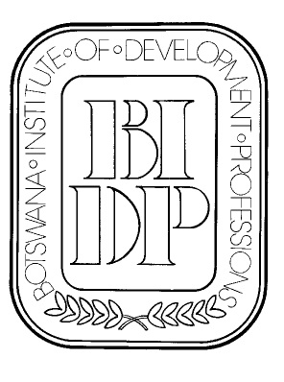
BOTSWANA INSTITUTE OF DEVELOPMENT PROFESSIONS

P.O. Box 827

Gaborone

Fax: 3971181
Mobile (Executive secretary): 7181 6811
e-mail: bidp@mega.bw
website: http//www.bidp.bw

16th August, 2010

TO ALL BIDP MEMBERS
Notice of the Annual General Meeting
The Botswana Institute of Development Professions will convene its 32nd Annual General Meeting on Thursday, 23rd September, 2010 at National Museum Little Theatre room. The meeting will start at 18:00hrs
There will be snacks and a cash bar after the meeting.
The agenda will be as follows:
 | 1 |  | Introduction
 | 2 |  | Notice convening AGM
 | 3 |  | Apologies
 | 4 |  | Minutes of the 31st AGM and Matters arising
 | 5 |  | Treasurer's report
 | 6 |  | President's report
 | 7 |  | Election of Officers
 | 8 |  | Any other Business
Please advise the executive secretary if you have a nomination for council. Posts are:

 | Name | Proposer | Seconder | Accepted nominee
President
Vice President
Secretary
Treasurer
and at least two members
Member (2/2 years)
Member (1/2 years)
S Ngwato continues for second year of her 2 year term

Proxy form is attached:

All members are cordially invited.

Andreas Groth
President, BIDP

