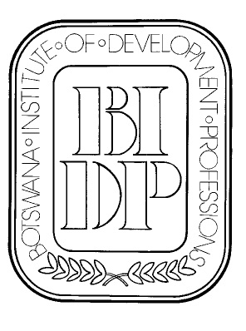
BOTSWANA INSTITUTE OF DEVELOPMENT PROFESSIONS

P.O. Box 827

Gaborone

Fax: 3971181
Mobile (Executive secretary): 7181 6811
e-mail: bidp@mega.bw
website: http//www.bidp.bw

19th September 2013

TO ALL BIDP MEMBERS
Notice of the Annual General Meeting
The Botswana Institute of Development Professions will convene its 35th Annual General Meeting on Tuesday, 15th October, 2013 at the Botswana Craft. The function will start at 18:00hrs
There will be a talk by *****
After the intermission, we shall proceed with the AGM.
There will be snacks after the talk.
The AGM agenda will be as follows:

 | 1 |  | Introduction
 | 2 |  | Notice convening AGM
 | 3 |  | Apologies
 | 4 |  | Minutes of the 34th AGM and Matters arising
 | 5 |  | Treasurer's report
 | 6 |  | President's report
 | 7 |  | Election of Officers
 | 8 |  | Any other Business

Please advise the executive secretary ahead of the meeting if you have a nomination for council. Posts are:

 | Name | Proposer | Seconder | Accepted nominee
President
Vice President
Secretary
Treasurer
and at least two members
Member (2/2 years)
Member (1/2 years)

A proxy form is attached:

All members are cordially invited.

ANNUAL GENERAL MEETING – 2013

PROXY VOTING FORM

I, .......................................................................being a fully paid up

member of the Botswana Institute of Development Professions hereby

appoint ............................................................................ as my proxy for any

vote that has to be made at the 2013 Annual General Meeting of the

Botswana Institute of Development Professions.

Signed: ................................................

Date: ................................................

