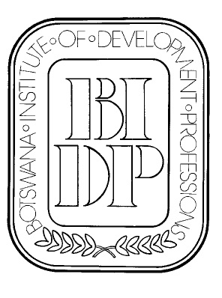
BOTSWANA INSTITUTE OF DEVELOPMENT PROFESSIONS

P.O. Box 827

Gaborone

Fax: 3971181
Mobile (Executive secretary): 7181 6811
e-mail: bidp@mega.bw
website: http//www.bidp.bw

23rd September, 2013

Dear Member,

RE: BIDP ANNUAL GENERAL MEETING

BIDP Members are cordially invited to attend the Annual General Meeting which will be held on Tuesday, 15th October, 2013 at Botswana Craft (Mogopong Conference) starting at 18:00hrs.

Attached is the AGM Notice.

Attached also is the proxy form (proxy forms are only meant for members who are not able to attend the AGM).

Snacks will be served after the AGM,

Please confirm your attendance with Executive Secretary, BIDP at bidp@mega.bw or 71816811.

Thank you and kind regards.

Yours Faithfully,


Ellen Tshoganetso

Executive Secretary, BDIP

